

Technical Solution Design

for

Space Range and Display
Store Range System

Version: 1.6

Document Type | Document Version | Authorized By
For File Layout Changes | 1.6 | ITPO

REVISION HISTORY

Version  Number | Date  (dd-mm-yyyy) | Author | Description
0.2 | 07-02-2007 | Clive Mizen | Initial draft
0.3 | 16-02-2007 | Clive Mizen | Initial draft
0.4 | 21-03-2007 | Clive Mizen | Initial draft. Cut taken just before SEL.
0.5 | 27-03-2007 | Clive Mizen | Initial draft. Cut taken just after sending 0.4 to Srikanth Rangarajan.
0.6 | 03-04-2007 | Clive Mizen | Initial draft. Cut taken just after sending 0.5 to Mary Welch & John Cowper.
0.9 | 11-04-2007 | Clive Mizen | New version after rejection of new data model. This was in versions 0.7 & 0.8.
0.10 | 12-04-2007 | Clive Mizen | New Data Model re-adopted.
0.11 | 16-04-2007 | Clive Mizen | For Review – released to & Architects Developers for final review and walkthrough before sign-off version.
0.12 | 18-0402007 | Clive Mizen | Half way thru review changes. Cut taken to issue to Mary Welch.
0.13 | 22-0402007 | Clive Mizen | Version to use 3rd version of Data Model.
1.0 | 25-04-2007 | Clive Mizen | Final version. For Sign Off.
1.1 | 25-04-2007 | Clive Mizen | Amended version – now for review due to volume of changes.
1.2 | 15-05-2007 | Clive Mizen | Further changes after review.
1.3 | 25-05-2007 | Clive Mizen | Amended to include up to date spec for S057 load.
1.4 | 07-06-2007 | Viswanathan Kannan | Amended file layouts finalized after discussion with Integration Team and Jacqueline Thomson
1.5 | 14-06-2007 | Viswanathan Kannan | Corrections, Physical Data model updated, SR39 logic amended as per query resolution and Physical Interface Numbers prefix changed and Output File names changed.
1.6 | 27-06-2007 | Viswanathan Kannan | Change in SR57 logic when setting up EndDate in Tables
TABLE OF CONTENTS

1. Overview 5
1.1 Solution Summary/Approach 5
1.2 Contacts 5
1.2.1 Sub-System Experts 5
1.2.2 Business IT contacts 5
1.3 Associated Documents. 6
2. Architecture Diagram 7
3. Technical Details 8
3.1 Platform 8
3.2 Data Communication 8
3.3 Database design 9
3.3.1 Database Model / Schema – Logical. 10
3.3.2 Database Model / Schema – Physical. 11
3.3.3 Table definitions. 12
3.4 Coding standards 12
File Load template. 13
3.5 File Extract template. 15
3.6 Error reporting. 16
4. Approach to Implement Non Functional Requirements 16
5. Detail Design 17
5.1 List of Components/Controls/Screens 17
5.2 List of Batch Programs 18
5.2.1 Scheduling 18
5.2.2 Interface - SR57 Store Range – Input from JDA. 18
5.2.3 Interface - SR31 Product In Location – Input from JDA. 18
5.2.4 Interface - SR77 Actual Range In Store - Input from GFO. 18
5.2.5 Interface - SR94 Central Discontinuations – Input from Spreadsheet. 18
5.2.6 Interface - SR89 Store – Input from IDS. 18
5.2.7 Interface - SR87 Product – Input from IDS. 18
5.2.8 Interface - SR47 GFO Replenishment – Output to GFO. 18
5.2.9 Interface - SR95 GFO Capacity – Output to GFO. 19
5.2.10 Interface - SR49 SRD ORMS Status Update – Output to RMS. 19
5.2.11 Interface - SR39 SEL Range – Output to Storeline. 19
5.2.12 Interface - SR92 SEL Display – Output to Storeline. 19
5.2.13 Interface - SR93 Location Sequence – Output to Storeline. 19
5.2.14 Housekeeping. 19
5.3 Design of algorithms (Business Logic/ Processing) 20
5.3.1 Scheduling 20
5.3.2 Process Interface - SR57 Store Range – Input 20
5.3.3 Process Interface - SR31 Product In Location – Input 24
5.3.4 Process Interface - SR77 Actual Range In Store - Input 26
5.3.5 Process Interface - SR94 Central Discontinuations – Input. 28
5.3.6 Process Interface - SR89 Store - Input. 29
5.3.7 Process Interface - SR87 Product – Input. 30
5.3.8 Process Interface - SR47 GFO Replenishment – Output. 31
5.3.9 Process Interface - SR95 GFO Capacity – Output. 34
5.3.10 Process Interface - SR49 SRD ORMS Status Update – Output. 37
5.3.11 Process Interface - SR39 SEL Range – Output. 39
5.3.12 Process Interface - SR92 SEL Display – Output. 43
5.3.13 Process Interface - SR93 Location Sequence – Output. 44
5.3.14 Process Housekeeping. 45
5.4 File Definitions. 46
5.4.1 Interface Files to Internal Name X-REF. 46
5.4.2 Interface Files Summary 46
5.4.3 SR31 Planogram Product Position (JDA to SR). 47
5.4.4 SR57 Store Range (JDA to SR). 48
5.4.5 SR77 Actual Range In Store (GFO to SR). 48
5.4.6 SR94 Central Discontinuations (SpreadSheet to SR). 49
5.4.7 SR89 Store (IDS to SR). 49
5.4.8 SR87 Product (IDS to SR). 49
5.4.9 SR47 GFO Replenishment (SR to GFO). 50
5.4.10 SR95 GFO Capacity (SR to GFO). 50
5.4.11 SR49 SRD ORMS Status Update (SR to ORMS). 51
5.4.12 SR39 SEL Range – (SR to Storeline). 51
5.4.13 SR92 SEL Display – (SR to Storeline). 52
5.4.14 SR93 Location Sequence (SR to Storeline). 52
5.5 Job Dependency / Run Frequency 53
5.6 Error messages 53
5.7 Special processing notes 53
5.8 Assumptions 53
5.9 Limits 54
5.10 Exception handling 54
6. Open Issues 54
7. Project Phase Sign-Off 54

Overview
This TSD covers the Technical Design for the whole of the Store Range system.
Store Range is an application that forms part of the Store Range and Display suite of applications within Tesco Operational Model.
The core function of the application is:
- To hold the proposed range for Stores and the Actual Range for Store and communicate differences to the replenishment system.
- Hold Capacity & Location data for communication to other downstream systems.
- Calculate and send Shelf Edge Label data to the in Store system.

The system has a low to medium level of complexity and is business critical.

See also the SAD for overview.

Solution Summary/Approach
The approach put forward in this design is to have a batch system consisting of a single database; the application software will reside within this DB as Stored Procedures.
The functionalities within this design meet the following high level requirements:
- The Ranging system must hold the centrally proposed range for a Store
- For Ranging event, the system must calculate changes to the proposed range for a Store
- The system must be able to report on the Store’s ranging position
- The system must be able to provide extracts to the GFO system to automate ordering
- The system must provide planogrammed capacities to GFO
- The system must provide an extract to Storeline with correct range and display indicators for Shelf Edge Labels
- The system must update the product/ location(Store) status in ORMS at the appropriate time
- The system will be able to hold and maintain instances of the same product in different display groups/planograms within the same Store (this includes products on promotional ends/planograms)
- The system will support the requirement to allow products to be discontinued from a Store’s range without having the need to build a new planogram
- The system must support Local Ranging

The system in scope here is Store Range System.

Contacts

Sub-System Experts

Sub-System | Contact Person
Store Range System | Jacqueline Thomson
Store Range System | John Cowper
Store Range System | Clive Mizen

Business IT contacts

Sub-System/ Module name | Contact Person
Store Range System | Steve Miller

Associated Documents.

Document Name | Version | Author | Issue Date | Filename
Business Requirements Definition For Space Range and Display  Store Range Database  Version: 0.2 | 0.2 | Jacqueline Thomson | 02-07 | Store Range BRD0.2.doc
Business System Design For  Space Range and Display  - Store Range System  Version: 1.2 For Sign off | 1.2 | Jacqueline Thomson | 26-04-07 | Store Range BSD1.2.doc

Architecture Diagram
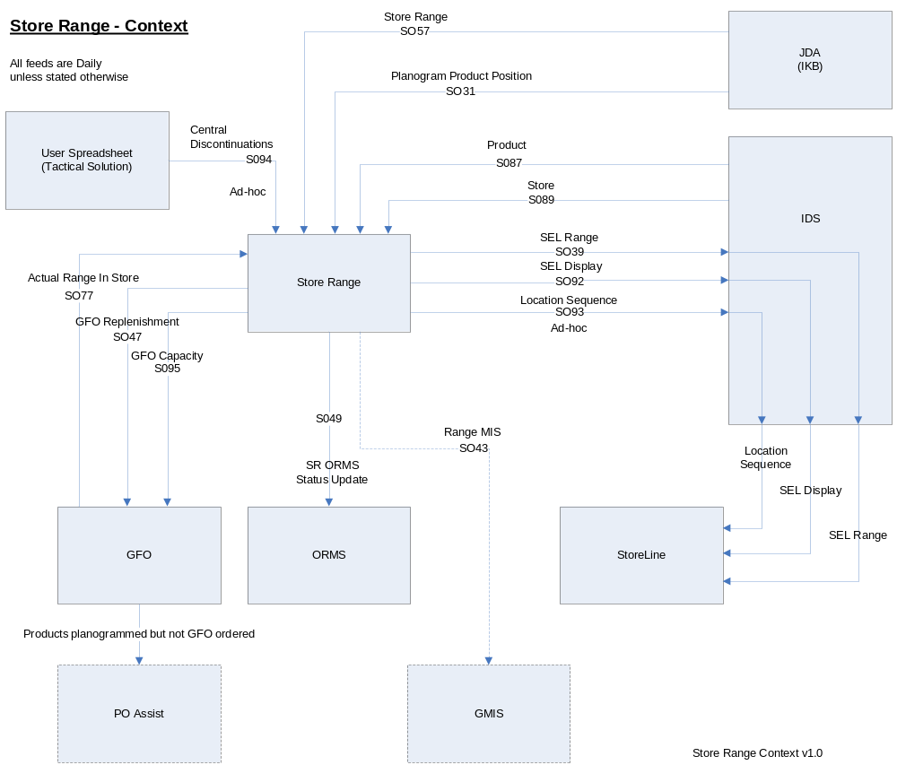

Technical Details

Platform
The platform is Windows 2003 Server Standard Edition with the latest Tesco approved service pack installed.
The RDBMS is SQL Server 2005.

Data Communication
This will take place by use of TOM Integration - the Integration Layer for Group IT.
The mechanism will be as follows:

- 2 folders on the production server are defined as shares, one for Input to SR from upstream systems, one for Output to downstream systems.
- The Integration layer will place files in the input folder.
- SR will write to files in the Output share. The Integration layer will detect the presence of the file and from its naming pattern then pass it on to the relevant downstream system.

The formats and layouts of all the interface files in SR are detailed in section 5.4 File Definitions.

Database design

<Explain the database design here, mention the different tables, fields, their properties, integrity constraints, uniqueness, foreign key, primary key etc., Also explain the scheme details and their sizing. If the database is distributed, develop the distribution strategies and list them here. OR a reference to the database design document that contains all the required and relevant details is sufficient. >

Database Model / Schema – Logical.
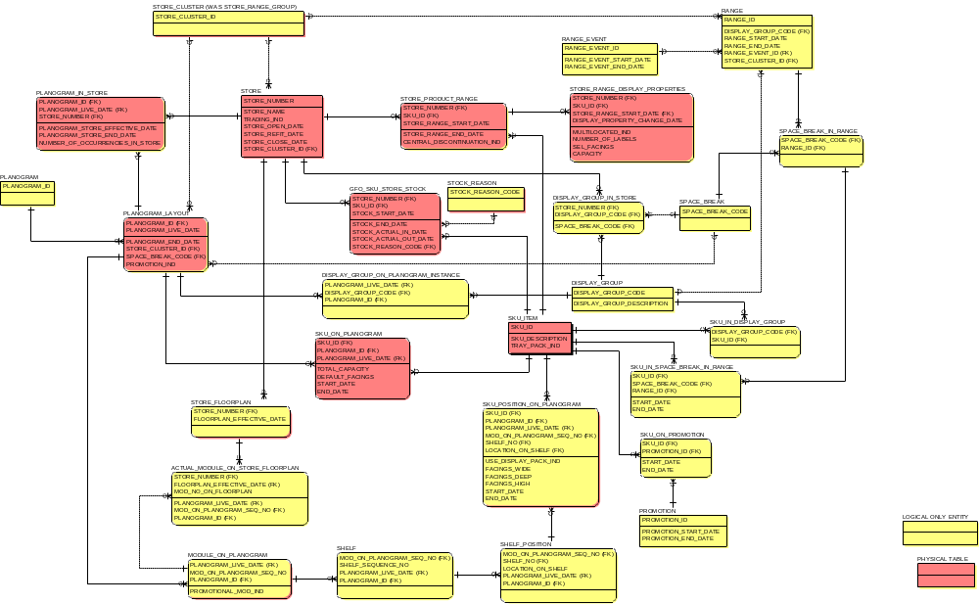

Database Model / Schema – Physical.
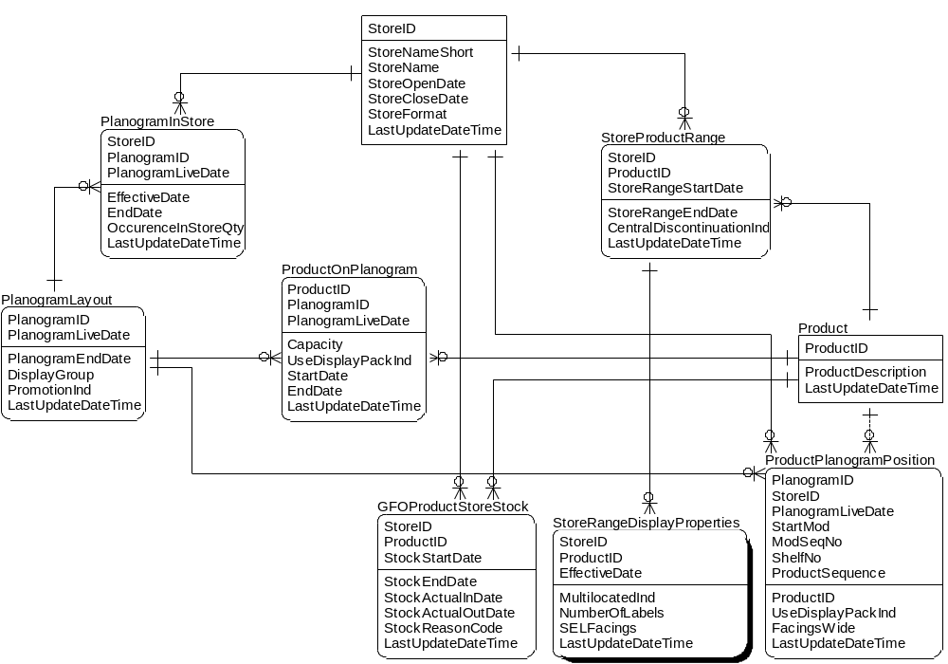
This does not include the
Non Functional Requirements Tables.

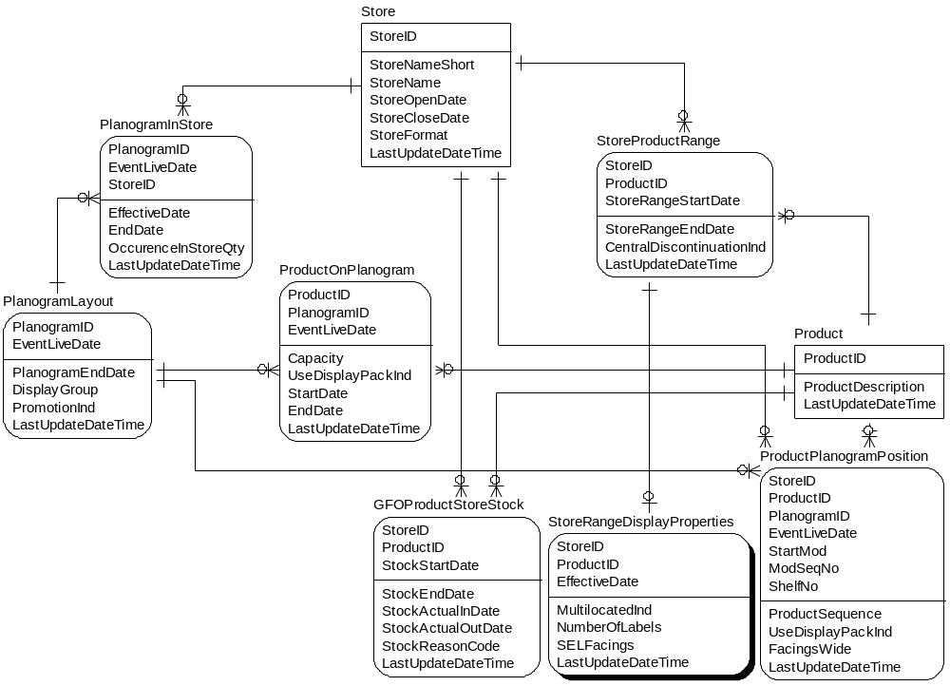

Table definitions.
See current DDL..

Coding standards
This project adopts the Tesco coding standards for T-SQL.

File Load template.
A template Stored Procedure for file loads should be in place for the development of this system.
It will have the following functionality:

Each Load program will be invoked by CA Autosys.
It will be populated with a single parameter of @FileName passed to the program which is the file name that has been delivered to the Input folder on the server.
The procedure should expect a second optional parameter which if present should be set to FORCE, which means ignore date validation.
The path to the Input folder is held on table Parameter.

Start of run:
- Set release e.g.: select @Release = '01.01.0001'
- Set return code e.g.: select @c_ReturnValue_Success = 0, @c_ReturnValue_Warning = 1, @c_ReturnValue_Failed = 2
- Log Start by writing an entry to Table RunLog

Get run data from table Parameter:
- Get Business Date e.g.: @BusinessDate = ‘Business Date’
- Set path to input folder e.g.: @InputPath = ‘Input Path’
- Set path to input file archive folder e.g.: @ArchivePath = ‘Archive Input Path’
- Set path to input file e.g.: @PathAndFile = @InputPath + @Filename
- Check that Load file exists
- BCP into temp table Temp_XX where XX describes the type of input.

Process header and footer details:
- Check if Header Exists
- Get Interface Date from Header and test if it is valid
- Compare the Interface Date from Header with the Business Date and test if they are matching
- Test if job has already run for the business day on table InterfaceHistory
- Use FORCE parameter to ensure that the job is re-run on the same business day.
- Check Trailer Exists
- Get Trailer Count
- Validate Trailer Count

Main Logic.
Main load logic in here.
End Of Run.
- Drop Temporary Tables
- Move input file to archive directory
- Write to InterfaceHistory
- Log end to table RunLog
- Return value

Invalid Data.
When loading records from the input file there are 2 scenarios,
- Rejected Data
- Discarded Data
Hence the 2 columns on InterfaceHistory.

Discarded Data.
Record is not loaded and 1 is added to discard count.
Do not write an entry to the windows application event log.

Rejected Data.
Record is not loaded, 1 is added to reject count and the record image is written to table RejectedData.
populate RejectedData as follows:

RejectedData
Column Name | Source
EntryDateTime | Current datetime
InterfaceName | Name of Interface Program
Release | Current release of Program
Reason | Description of error in free format descriptive English
DetailRecord | An exact image of the incoming record

File Extract template.
A template Stored Procedure for file extracts should be in place for the development of this system.
It will have the following functionality:

Each Extract program will be invoked by CA Autosys.
The integration layer will be polling the Output folder for the presence of any file that is written to it.
Based on the pattern of the file name it will send the file on to the required destination system.
The path to the Output folder is held on table Parameter.

Standard Extract Processing:
- Set release e.g.: select @Release = '01.01.0001'
- Set return code e.g.: select @c_ReturnValue_Success = 0, @c_ReturnValue_Warning = 1, @c_ReturnValue_Failed = 2
- Log Start by writing an entry to Table RunLog

Get filename from InterfaceExtractControl
Obtain @filename from InterfaceExtractControl where InterfaceName is given for interface program in section 5.4.1

Get run data from table Parameter:
- Set Business Date: @BusinessDate = ‘Business Date’
- Set path to output folder e.g.: @OutputPath = ‘Output Path’

- Set path to output file e.g.: @PathAndFile = @OutputPath + @Filname

Main Logic:
Main load logic in here.
This will build a Temp table to hold output from run.
End Of Run:
- Create Temp Output table with one column of length of the required output file.
- Insert Header into Temp Output table.
- Copy rows from build Temp Table from main logic, to Temp Output table.
- Insert Trailer into Temp Output table.
- Create clustered index on Temp Output table.
- BCP temp table to output file with an extension of .BCPINPROGRESS
- Check output file exists
- Rename the file to have Business Date and TimeStamp part of the file name and change the extension to .TXT
  - Format of the output file name <BusinessDate>_<Filename from InterfaceExtractControl>_<TimeStamp>.TXT
- Drop Temporary Tables

- Write to InterfaceHistory
- Log End to table RunLog
- Return value

Error reporting.

Error reporting will be performed by each Stored Procedure by writing to the Windows Event Log.
Standard alerting for TOM will be put in place. CA Unicentre will be used.

Approach to Implement Non Functional Requirements

Technical Requirement/  Design Goal | Implementation Approach | Section* ( For more details)
Security | Standard security for Tesco Database server.
Personalisation | None
Performance and Scalability | The standard build Tesco database server will provide more than adequate performance for the expected volumes of data and processing required.  Scalability can be provided by the standard infrastructure processes that are in place, DBA’s / WOF.
Usability:
User Interface | None
Integration with Online Help | None
Internationalization | None
Multi language | None
Reliability | This will be covered by standard infrastructure procedures, DBA’s / WOF.
Maintainability – Analysability | This will be covered by standard infrastructure procedures, DBA’s / WOF.
Availability | 24/7
Run Logs | Each program will log its start and end time to a database table created for this purpose.
File audit trail | Statistics on file volumes will be held on a database table created for this purpose.
Object release audit trail | Each program will record its release to the on a database table created for this purpose.

Detail Design

List of Components/Controls/Screens
SP = Stored Procedure
DBT = Database Table

Component Name | Type | New  Amend  Delete | See BSD Section:
USP_Load_SR57_StoreRange | SP | New | 3.1 Load Centrally Proposed Range for Stores  3.2 Update the Centrally Proposed Range
USP_Load_SR31_PlanogramProdPosition | SP | New | 3.7 Send Full Update of Location Sequence Storeline
USP_Load_SR77_ActualRangeInStore | SP | New | 3.3 Maintain Local Store Range (Actual Range)
USP_Load_SR94_CentralDiscontinuation | SP | New | 3.9 Tactical Solution to Manage Central Discontinuations
USP_Load_SR89_Store | SP | New | 3.10 Reference Data Requirements
USP_Load_SR87_Product | SP | New | 3.10 Reference Data Requirements
USP_Extract_SR47_GFOReplenishment | SP | New | 3.4 Identify Changes to Stocked Range
USP_Extract_ SR95_GFOCapacity | SP | New | 3.5 Maintain Capacity
USP_Extract_SR49_SRDORMSStatusUpdate | SP | New | 3.8 Maintain Item/Location status
USP_Extract_SR39_SELRange | SP | New | 3.6 Identify Range and Display extract for Shelf Edge Labels
USP_Extract_SR92_SELDisplay | SP | New | 3.6 Identify Range and Display extract for Shelf Edge Labels
USP_Extract_SR93_LocationSequence | SP | New | 3.7 Send Full Update of Location Sequence to Storeline
USP_HouseKepping | SP | New | NFR
Store | DBT | New
PlanogramLayout | DBT | New
PlanogramInStore | DBT | New
ProductOnPlanogram | DBT | New
Product | DBT | New
ProductPlanogramPosition | DBT | New
StoreProductRange | DBT | New
StoreRangeDisplayProperties | DBT | New
GFOProductStoreStock | DBT | New
GFOReplenishmentHistory | DBT | New
GFOCapacityHistory | DBT | New
ProductOnActualShelfPosition | DBT | New | Not used for Ver. 1
CentralDiscontinuation | DBT | New
Parameter | DBT | New | NFR
RunLog | DBT | New | NFR
ReleaseLog | DBT | New | NFR
InterfaceHistory | DBT | New | NFR
InterfaceExtractControl | DBT | New | NFR
RejectedData | DBT | New

List of Batch Programs

Scheduling
Scheduling will be controlled externally by CA Autosys.

Interface - SR57 Store Range – Input from JDA.
USP_Load_SR57_StoreRange

This is generated when a planogram/floorplan goes pending.
The data for entire related Store is sent even if it is only one planogram going pending.
Only the Stores that have a change are sent.

Interface - SR31 Product In Location – Input from JDA.
USP_Load_SR31_PlanogramProdPosition

This is generated when a planogram/floorplan goes live.
This is generated daily for all Stores that have changed.
The data for entire related Store is sent even if it is only one planogram going pending or has an effective date change.

Interface - SR77 Actual Range In Store - Input from GFO.
USP_Load_SR77_ActualRangeInStore

This is a daily feed of changes to Actual Range.
This is generated for all Products that have changed or are new.

Interface - SR94 Central Discontinuations – Input from Spreadsheet.
USP_Load_SR94_CentralDiscontinuation

Tactical Solution.
Ad-hoc.
The list of Product discontinuations will be held on a spreadsheet.
This data will be extracted and loaded onto a database table as total refresh, the data held on the database table will be used in all calculations of products that are ending.
This data will remain static until such time as the spreadsheet has been amended and then re-loaded.

Interface - SR89 Store – Input from IDS.
USP_Load_SR89_Store

Daily.

Interface - SR87 Product – Input from IDS.
USP_Load_SR87_Product

Daily.

Interface - SR47 GFO Replenishment – Output to GFO.
USP_Extract_SR47_GFOReplenishment

A daily feed to GFO informing it of stock changes, either new or discontinuations
This is performed by comparing the data for the Centrally Proposed Range (CPR) held on PlanogramInStore & ProductOnPlanogram from feed SR57 from JDA.

Interface - SR95 GFO Capacity – Output to GFO.
USP_Extract_SR95_GFOReplenishment

A daily feed to GFO informing it of Capacity values for new Products coming into Store or changes in Capacity values for Products where the Capacity has been sent previously.
Separate records will be sent for Products on Planograms that are on Promotion.

Interface - SR49 SRD ORMS Status Update – Output to RMS.
USP_Extract_SR49_SRDORMSStatusUpdate

A daily feed to ORMS.
Products starting and ending in the activity window.

Interface - SR39 SEL Range – Output to Storeline.
USP_Extract_SR39_SELRange

A daily feed to Storeline via the IDS.
Indicator values for Products that have in Store movements planned for the future.

Interface - SR92 SEL Display – Output to Storeline.
USP_Extract_SR92_SELDisplay

A daily feed to Storeline via the IDS.
Indicator values for Products that have in Store movements planned for the future.

Interface - SR93 Location Sequence – Output to Storeline.
USP_Extract_SR93_LocationSequence

An Ad-hoc feed to Storeline via the IDS.

Housekeeping.
USP_HouseKeeping

This program will:
Zip all files received for the Business Day in the ArchiveIn folder into one file.

Roll Business Date forward 1 day.

Design of algorithms (Business Logic/ Processing)

Scheduling
Scheduling will be controlled by CA Autosys.
See section ‘5.4 Job Dependency / Run Frequency’.

Process Interface - SR57 Store Range – Input
From BSD 3.1 Load Centrally Proposed Range for Stores
Update the Centrally Proposed Range.

Program/Stored Procedure name: USP_Load_SR57_StoreRange

The interface name for this extract is: SR57-SR-IN

Obtain Parameters

SR57 Parameters
Abrev | Meaning | Parameter.ParameterName | Typical  Value
BD | Business Date | Business Date | 2007-05-24
SRW | Store Range Window period in days | Store Range Window | 21
NSSO | New Store Start Offset days | New Store Start Offset | 3
- | Path where the input file must be placed | Input Path | D:\SRInput
- | Path where the input file would be placed after load | Archive Input Path | D:\SRArchiveIn

Input file structure.
The input file is a detail level feed of data at Product level.
The key is Store/Planogram/Product.

The way JDA decides how to send down data is based on when a Planogram goes ‘Pending’ this will be because it is brand new or it has changes. When a Planogram is new the EventLiveDate will be the date at which it goes live in Store. When a Planogram has changes the EventLiveDate will have a different value, this date is the date at which the changes take effect.
Any new or changed Planogram will cause ALL data for that Store to be sent down.
It is therefore possible that a set of data for a Planogram (within that Store) will be exactly the same as previously sent, this is because nothing has changed for it (please note the EventLiveDate will still be the same), but another Planogram in it’s store has changed.

- A Planogram can be present in more than one Store.
- A product can be present on more than one Planogram within a Store.
- Multiple records for one Planogram may be present – e.g.: The Planogram for Chewing Gum may be present at all 16 checkouts; therefore there will be 16 occurrences. They can be differentiated by different values in StartMod, but this is only present in SR31 not SR57!. In SR57 we are interested in Total Capacity, total number of Labels. So from the multiple records for one Planogram, derive a single record summing up the values in Capacity, NumberOfLabels columns

When a Planogram ends within a Store, we will not be explicitly notified of this, the way to determine this is the absence of the Planogram (see logic below).

Store updates present
An overall rule will apply to the checking below – only check for missing Products in a Store when we have had records present for that Store on the input file.

The following is a table by table set of rules for how they should be populated.

As a general principle anything with an EndDate will no longer be updated, and a new occurrence will be inserted, StartDate/EffectiveDate/EventLiveDate is present in the key of most tables.

Obtain ‘Store Range Window’ parameter from Parameters = SRW
Obtain ‘New Store Start Offset’ parameter from Parameters = NSSO

PlanogramInStore
Match on key, i.e.: StoreID, PlanogramID, EventLiveDate
When checking present on table ignore rows where EndDate is not null.

- Present on file - not present on table and no other row exists for Store/Planogram:
Insert new row, EffectiveDate set to EventLiveDate.
- Present on file - Present on table:
Please refer to Attribute Changes section.
- Present on file - not present on table but another row(s) exists for Store/Planogram:
Insert new but set EffectiveDate = EffectiveDate from previous occurrence of row.
- Not Present on file - Present on table:
i.e. the Planogram is being removed from the store. Set EndDate = Latest EventLiveDate from the Input file for the Store from the Planograms which exists in the Input file (as there will not be any record in the input file with the Planogram being removed) for all occurrences of the StoreID/PlanogramID combination.

PlanogramLayout
Match on key, i.e.: PlanogramID, EventLiveDate
When checking present on table ignore rows where PlanogramEndDate is not null.

- Present on file - Present on table:
Please refer to Attribute Changes section.
- Present on file - not present on table:
Insert new row.
- Not Present on file - Present on table:
Do nothing. (Since a Planogram can still be present in more than one Store and if there have been no changes for a Store it may still exist but just was not sent today)

ProductOnPlanogram
Match on: ProductID, PlanogramID, EventLiveDate
When checking present on table ignore rows where EndDate is not null.
When checking StoreProductRange table ignore rows where StoreRangeEndDate is not null.

- Present on file Present on table:
Please refer to Attribute Changes section.
- Present on file - not present on table and no other row exists for PlanogramID/ProductID:
Insert new row, StartDate set to EventLiveDate.
Also:
Check StoreProductRange table,
If a row exists for this StoreID/ProductID:
check StoreRangeStartDate against EventLiveDate,
If EventLiveDate < StoreRangeStartDate:
Delete existing row,
Insert new row, set StoreRangeStartDate = EventLiveDate.
If no row exists for StoreID/ProductID:
Insert a row into StoreProductRange, set StoreRangeStartDate = EventLiveDate.
- Present on file - not present on table but another other row exists for PlanogramID/ProductID:
Insert new but set StartDate = StartDate from previous occurrence of row.
- Not Present on file - but Present on table:
This means the Product is being removed from the Planogram.
- If the product is removed from the Planogram but the Planogram exists in the input file with other Products, then set the EndDate for the Product which is removed from the Planogram
i.e. Set EndDate = EventLiveDate of the Planogram in the input file
- But if the entire Planogram is removed from all the stores, then Set EndDate = End date of the last Planogram Store relationship ending in the Store, the event that removes the product from the store.
i.e. Latest EventLiveDate from the Input file for the Store from the Planograms which exists in the Input file (as there will not be any record in the input file for the Planogram being removed)
for all occurrences of the Planogram/Product combination where EndDate is null,
Also:
Check in the Input file (in the Temp table we created out of it) for the presence of Store Product combination irrespective of the PlanogramID+EventLiveDate, and if the Product is not present anywhere in the Store in the input file, i.e. a Product is removed from all the Planograms in the Store. Set the StoreRangeEndDate = EventLiveDate of the event which removes the last Store + Product relationship in the Store.

StoreProductRange
Rules are given in ProductOnPlanogram above.

StoreRangeDisplayProperties
- This table goes hand-in-hand with the StoreProductRange.
- As per the Rules for StoreProductRange, whenever a StoreProductRange row is deleted, the corresponding (matching on StoreID=StoreID/ProductID=ProductID/EffectiveDate=StoreRangeStartDate) StoreRangeDisplayProperties row must be deleted first before the StoreProductRangeRow is deleted
- Whenever a StoreProductRange row is inserted a StoreRangeDisplayProperties row also will be inserted after the StoreProductRange row is inserted.
- Only when a StoreProductRange is updated setting the StoreRangeEndDate = BD + 21 (parameter), there will not be any action on StoreRangeDisplayProperties table (as this row would become an orphan row, and Housekeeping procedures (future) should remove them eventually).

Skim & Fill processing for New Stores
Assumption: Store data will be sent in advance.
If a record comes in for a Store that has never been present before (ignore Store table). (Check for StoreID’s presence in StoreProductRange table, if it has no match in the entire table, then consider it for Skim and Fill) Set ProductOnPlanogram.StartDate to BD + 3 and StoreProductRange.StoreRangeStartDate to BD + 3.
The 3 will actually be a parameter ‘New Store Start Offset’ (NSSO)

Attribute Changes

Where a record exists on the file and in the following 3 tables inner joined together:
PlanogramInStore, PlanogramLayout & ProductOnPlanogram,
Using the 4 key values from the file:
StoreID
ProductID
PlanogramID
EventLiveDate
as appropriate join to the following tables and check if any of the following columns have different values:

Table(s) | From File
Column Name | Source
PlanogramLayout.PromotionInd | Promotional indicator
PlanogramLayout.DisplayGroup | DisplayGroup
ProductOnPlanogram.Capacity | Capacity
ProductOnPlanogram.UseDisplayPackInd | SRP Indicator
StoreRangeDisplayProperties.NumberOfLabels | Number of Labels
StoreRangeDisplayProperties.MultiLocatedInd | Multilocated Indicator
StoreRangeDisplayProperties.SELFacings | SELFacings
PlanogramInStore.OccurenceInStoreQty | OccurenceInStoreQty

If any have changed update the table row with the new values.
Update LastUpdateDateTime to current datetime in the corresponding table.

CentralDiscontinuation Processing

Discontinuation:

Input available:
StoreID, ProductID, EndDate as the input from CentralDiscontinuation table

StoreProductRange:
If End date is not null and Start Date is null in the CentralDiscontinuation then discontinue the product in the store by setting the StoreRangeEndDate = CentralDiscontinuation.EndDate in the StoreProductRange table.

ProductOnPlanogram:
No Action

Reinstatement:

Input available:
StoreID, ProductID, StartDate and PlanogramID as the input from CentralDiscontinuation table.

StoreProductRange:
Update the matching Store + Product combination record set StoreRangeStartDate = CentralDiscontinuation.StartDate value and StoreRangeEndDate = NULL
Note: Assuming that there will not be any active StoreID + ProductID combination at this point in the StoreProductRange table.

ProductOnPlanogram:
Match the matching ProductID + PlanogramID and get the latest PlanogramID + EventLiveDate record for the store in the ProductOnPlanogram table joined with PlanogramInStore and check if CentralDiscontinuation.StartDate < StartDate in the matching record, If yes, then update the record by setting the StartDate = CentralDiscontinuation.StartDate and EndDate = null.

End of processing
When all detail records have been processed and data from CentralDiscontinuation has been included in the update, perform end of load activities as described in the standard template in Section 3.5.

Process Interface - SR31 Product In Location – Input
From BSD 3.7 Send Full Update of Location Sequence to Storeline.

Program/Stored Procedure name: USP_Load_SR31_PlanogramProductPosition

The interface name for this extract is: SR31-PPP-IN

Obtain Parameters

SR31 Parameters
Abrev | Meaning | Parameter.ParameterName | Typical  Value
BD | Business Date | Business Date | 2007-05-24
- | Path where the input file must be placed | Input Path | D:\SRInput
- | Path where the input file would be placed after load | Archive Input Path | D:\SRArchiveIn

This is a delta file – i.e.: contains changes only.
The input file will be structured as follows:
Records will only be present for Stores that have had a change of data since the last update.
Any data change in a Store will cause ALL records for that Store to be transmitted.

See Section 5.4.3 for a record layout description of the input file.

This feed will update the ProductPlanogramPosition table.
Records will only be present for Store that have had a change of data since the last update.
Any data change in a Store will cause all records for that Store to be transmitted.

Start of run processing.
Perform start of load activities as described in the standard template in Section 3.5.

Logic:
For each detail record present on input file - DetailRECTYPE = ‘1’.
For each Store present on input file:
If any of the rows on Store/PlanogramLayout/PlanogramInStore/Product do not exist on table Store
Do not process this record.
Do not process this record.

Perform a match on ProductPlanogramPosition on the following key:
StoreID
PlanogramID
PlanogramLiveDate
StartMod
ModSeqNo
ShelfNo

if the row already exists update as follows:
ProductPlanogramPosition | Input File
Column Name | Source
ProductSequence | ProductSequence
ProductID | Product Number
FacingsWide | Facings wide
LastUpdateDateTime | current datetime

Else if no row present insert one with the following values
ProductPlanogramPosition | Input File
Column Name | Source
StoreID | StoreID
PlanogramID | Planogram ID
PlanogramLiveDate | PlanogramLiveDate
StartMod | Start Mod
ModSeqNo | Mod Sequence
ShelfNo | Shelf ID
ProductSequence | Product Sequence
ProductID | Product Code
UseDisplayPackInd | spaces
LastUpdateDateTime | current datetime

End of processing.
When all detail records have been processed and data from CentralDiscontinuation has been included in the update,
perform end of load activities as described in the standard template in Section 3.5.

Process Interface - SR77 Actual Range In Store - Input
From BSD 3.3 Maintain Local Store Range (Actual Range).

Program/Stored Procedure name: USP_Load_SR77_ActualRangeInStore

The interface name for this extract is: SR77-ARIS-IN

Obtain Parameters

SR77 Parameters
Abrev | Meaning | Parameter.ParameterName | Typical Value
BD | Business Date | Business Date | 2007-05-24
- | Path where the input file must be placed | Input Path | D:\SRInput
- | Path where the input file would be placed after load | Archive Input Path | D:\SRArchiveIn

This feed updates table GFOProductStoreStock.
This is a delta file – i.e.: contains changes only. Allow for an empty file – process header and trailer only then exit. The input file will be structured as follows:
Any additions or changes to Store/Product combinations in GFO will be communicated to SR on a daily basis.

See Section 5.4.5 for a record layout description of the input file.

Start of run processing.
perform start of load activities as described in the standard template in Section 3.5.

Logic:
Process detail record from file, Insert/Update GFOProductStoreStock.
For each detail record present on input file - DetailRECTYPE = ‘1’.
Check that the Store and the Product both exist in their respective tables. If either Store or Product do not exists then reject the record as described in Section 3.5 File Load template.

Perform a match to GFOProductStoreStock on the following key:
StoreID
ProductID
StockStartDate

Where a record exists on the file but not in table:
Insert a row into GFOProductStoreStock,
Populate the columns as follows:

GFOProductStoreStock | Input File
Column Name | Source
StoreID | Store Number
ProductID | Base Product
StockStartDate | Stock Start Date
StockEndDate | Stock End Date
StockActualInDate | Stock Reason Code
StockActualOutDate | Actual Range In Date
StockReasonCode | Actual Range Out Date
LastUpdateDateTime | current datetime

Where a record exists on the file and in the table
Update the following columns as follows:

GFOProductStoreStock | Input File
Column Name | Source
StockEndDate | Stock End Date
StockActualInDate | Actual Range In Date
StockActualOutDate | Actual Range Out Date
StockReasonCode | StockReasonCode
LastUpdateDateTime | current datetime

End of file processing.
When all detail records have been processed,
perform end of load activities as described in the standard template in Section 3.5.

Process Interface - SR94 Central Discontinuations – Input.
From BSD 3.9 Tactical Solution to Manage Central Discontinuations – Version 1 solution only.

Program/Stored Procedure name: USP_Load_SR94_CentralDiscontinuation

The interface name for this extract is: SR94-CENDISC-IN

This is a full refresh.

The input file is of CSV format with only 6 values, StoreID, ProductID, EndDate, StartDate, Reason, PlanogramID.
It is created by the user area from a spreadsheet that hold all the Central Discontinuations.
This program will be run on an ad-hoc basis.
The spreadsheet will be saved in CSV format and the resulting output file moved to the server by the support team and this will then be run manually by them.

Start of run processing.
Perform start of load activities as described in the standard template in Section 3.5.

Obtain Parameters

SR94 Parameters
Abrev | Meaning | Parameter.ParameterName | Typical Value
BD | Business Date | Business Date | 2007-05-24
- | Path where the input file must be placed | Input Path | D:\SRInput
- | Path where the input file would be placed after load | Archive Input Path | D:\SRArchiveIn

Logic.

Truncate the CentralDiscontinuation table
For each record on the file:
Insert a row into CentralDiscontinuation.

Populate the columns as follows:

CentralDiscontinuation | Input File
Column Name | Source
StoreID | Store Id
ProductNUmber | Product
EndDate | End Date
StartDate | Start Date
ChangeReasonCode | Reason
PlanogramID | Planogram ID
LastUpdatedDateTime | Current date

End of file processing.
When all records have been processed,
perform end of load activities as described in the standard template in Section 3.5.

Process Interface - SR89 Store - Input.
From BSD 3.10 Reference Data Requirements.

Program/Stored Procedure name: USP_Load_SR98_Store

The interface name for this extract is: SR89-STORE-IN

This is a full refresh.

Start of run processing.
Perform start of load activities as described in the standard template in Section 3.5.

Obtain Parameters

SR89 Parameters
Abrev | Meaning | Parameter.ParameterName | Typical Value
BD | Business Date | Business Date | 2007-05-24
- | Path where the input file must be placed | Input Path | D:\SRInput
- | Path where the input file would be placed after load | Archive Input Path | D:\SRArchiveIn

Logic.

For each detail record present on input file - DetailRECTYPE = ‘1’.
Validate the following fields:
Open Date
Close Date
If either are not valid dates reject the record as described in the Load template – section 3.5.

Compare the Store Number form the file to the table Store.
match Store Number to StoreID.

If the row for the Store already exists then update the row with fields from the input file as in the mappings table below.

If the row for the Store does not exist exists then insert a row with fields from the input file as in the mappings table below.

Input file to table Store mappings.

Store | Input File
Column Name | Source
StoreID | Store Number
StoreNameShort | Store Name Short
StoreName | Store Name
StoreOpenDate | Open Date
StoreCloseDate | Close Date
StoreFormat | Format
LastUpdateDateTime | current date time

End of file processing.
When all records have been processed,
perform end of load activities as described in the standard template in Section 3.5.

Process Interface - SR87 Product – Input.
From BSD 3.10 Reference Data Requirements.

Program/Stored Procedure name: USP_Load_SR87_Product

The interface name for this extract is: SR87-PROD-IN

This is a full refresh.

Start of run processing.
Perform start of load activities as described in the standard template in Section 3.5.

Obtain Parameters

SR87 Parameters
Abrev | Meaning | Parameter.ParameterName | Typical Value
BD | Business Date | Business Date | 2007-05-24

Logic.

For each detail record present on input file - DetailRECTYPE = ‘1’.

Compare the Store Number form the file to the table Product.
match Product Number to ProductID.

If the row for the Product already exists then update the row with fields from the input file as in the mappings table below.

If the row for the Product does not exist exists then insert a row with fields from the input file as in the mappings table below.

Input file to table Product mappings.

Product | Input File
Column Name | Source
ProductID | Product
ProductDescription | ProductDescription
LastUpdateDateTime | current date time

End of file processing.
When all records have been processed,
perform end of load activities as described in the standard template in Section 3.5.

Process Interface - SR47 GFO Replenishment – Output.
From BSD 3.4 Identify Changes to Stocked Range.

Program/Stored Procedure name: USP_Extract_SR47_GFOReplenishment

The interface name for this extract is: SR47-GFOREPLEN-OUT

Start of run processing.
Perform start of extract activities as described in the standard template in Section 3.6.

Obtain Parameters

SR47 Parameters
Abrev | Meaning | Parameter.ParameterName | Typical Value
BD | Business Date | Business Date | 2007-05-24
- | Path where the output file must be placed | Output Path | D:\SRoutput
- | GFO Replen Window End | GFO Replen Window End | 21
Interface ExtractControl Extract Filename
- | Interface Name | InterfaceName | SR47-GFOREPLEN-OUT
- | Extract FileName | FileName | SR47_GFOExtractFile

Compare StoreProductRange to GFOProductStoreStock.
Table StoreProductRange will hold the earliest Start Date for Products that are on multiple Planograms. This resolution of multiple Products for a Store (i.e.: multiple Planograms) being present is handled in the load Store Range load SR57.

Create a temp table Temp_ProductsMaxMinDate with the following columns:
StoreID
ProductID
StartDate
EndDate
Populate it with unique rows from StoreProductRange
where (EndDate between Start of Window and End of Window)
or (StartDate between Start of Window and End of Window).

The following temp table will be products that are in the ProductInPlanogram but not present in GFOProductStoreStock, these are therefore new.
Create temporary table Temp_NewProducts with the following columns:
StoreID
ProductID
StartDate
Populate it with rows from Temp_ProductsMaxMinDate outer joined to GFOProductStoreStock .
Where rows are not present in GFOProductStoreStock then
The outer join should match on the following:
StoreID
ProductID
where StockStartDate in is the window.

If the rows are present in GFOProductStoreStock then
The outer join should match on the following:
StoreID
ProductID
where
GFOProductStoreStock.stockstartdate >= Temp_ProductsMaxMinDate.startdate
and GFOProductStoreStock.stockenddate< Temp_ProductsMaxMinDate.enddate

The following temp table will be products that are not in the ProductOnPlanogram but are present in GFOProductStoreStock which means they should be discontinued. Do not discontinue Products that are still active beyond window.
Create temporary table Temp_DiscontinuedProducts with the following columns:
StoreID
ProductID
EndDate
Populate it with rows from Temp_ProductsMaxMinDate by outer joining it to GFOProductStoreStock where are not present in Temp_ProductsMaxMinDate.
The outer join should match on the following:
StoreID
ProductID
where EndDate is in the window.

Compare Selected rows to History.
Delete from Temp_NewProducts where rows exists in GFOReplenishmentHistory
matched on:
StoreID
ProductID
Where
GFOReplenishmentHistory.sentDiscDate is null
and
GFOReplenishmentHistory.sentNewDate<=Temp_NewProducts.StartDate

Insert into GFOReplenishmentHistory all rows from Temp_NewProducts

Delete from Temp_DiscontinuedProducts where exists in GFOReplenishmentHistory
matched on:
StoreID
ProductID
Where
GFOReplenishmentHistory.SentDiscDate <=Temp_DiscontinuedProducts.EndDate

Insert into GFOReplenishmentHistory all rows from Temp_ DiscontinuedProducts

Create Output Table.
The following temp table will become the source for the output file.
Create temporary table Temp_GFOReplenOutput with the following columns:
StoreID
ProductID
StartDate
EndDate

Populate Temp_GFOReplenOutput by inserting rows from Temp_NewProducts with the following column settings:

Temp_GFOReplenOutput
Column Name | Source
StoreID | Temp_NewProducts.Store
ProductID | Temp_NewProducts.Product
StartDate | Temp_NewProducts.StartDate
EndDate | null

Populate Temp_GFOReplenOutput by inserting rows from Temp_ DiscontinuedProducts with the following column settings:

Temp_GFOReplenOutput
Column Name | Source
StoreID | Temp_ DiscontinuedProducts.Store
ProductID | Temp_ DiscontinuedProducts.Product
StartDate | null
EndDate | Temp_ DiscontinuedProducts.StartDate

Follow the instructions in the File Extract section 3.6 for writing the Temp_GFOReplenOutput to the output file.

Populate the output flat file according to table SR47 Field Mappings.

SR47 Field Mappings.

File | Temp_GFOReplenOutput
Field Name | Column Name
StoreID | StoreID
ProductID | ProductID
Range Start Date | StartDate
Range End Date | EndDate

End of run processing.
When all processing complete:
perform end of extract activities as described in the standard template in Section 3.6.

Process Interface - SR95 GFO Capacity – Output.
From BSD 3.5 Maintain Capacity.

Program/Stored Procedure name: USP_Extract_SR95_GFOCapacity

The interface name for this extract is: SR95-GFOCAPACITY-OUT

Start of run processing.
Perform start of extract activities as described in the standard template in Section 3.6.

Obtain Parameters

SR95 Parameters
Abrev | Meaning | Parameter.ParameterName | Typical Value
BD | Business Date | Business Date | 2007-05-24
- | GFO Capacity Last Run Date | GFO Capacity Last Run Date | 2007-05-24
- | GFO Capacity Window End | GFO Capacity Window End | 21
- | Path where the output file must be placed | Output Path | D:\SRoutput
Interface ExtractControl Extract Filename
Meaning |  | InterfaceExtractControl column name | Expected Value
Interface Name |  | InterfaceName | SR95-GFOCAPACITY-OUT
Extract Filename |  | FileName | SR95_PlanogramCapacity

This extract will send a record to GFO due to 2 scenarios:
1) A Product is not currently in Store, its start date is now 21 days ahead of business date and we should send down the capacity value to GFO.
2) A Product is already in Store, new data for it has come in from JDA on feed SR57, check the Capacity value against the Capacity value held in the History table. If it different send a record to GFO again

A separation will be made for Products on Planograms that are promotional.

The History table will also hold the original date that the Product went live in Store, know as Effective Date.

Identify Changes to Products Capacity.
Obtain the GFO Capacity Window End value from Parameters table
where ParameterName = ‘GFO Capacity Window End’
Obtain Capacity Last Run Date value from Parameters table
where ParameterName = ‘GFO Capacity Last Run Date’

Create temp table with only latest EventLiveDate for a Planogram.
The following temp table will contain a single row for each live Planogram containing its latest EventLiveDate.
Create a temp table Temp_LatestPlanogramRows with the following columns:
PlanogramID
EventLiveDate
PromotionInd
by populating it with rows from PlanogramLayout as follows
select PlanogramLayout.PlanogramID, PlanogramLayout.PromotionInd max(PlanogramLayout .EventLiveDate)
where PlanogramLayout.EndDate is null
group by PlanogramID, PromotionInd

Temp table to hold Products starting in window or have changed since last run.
The join to StoreProductRange to obtain Start Date will ensure the earliest Start Date is found for this Product in Store.
Create a temp table Temp_ProductsCapacityChange with the following columns:
StoreID
ProductID
PromotionInd
Capacity
FacingsWide
EffectiveDate

Populating it as follows:
StoreID = PlanogramInStore. StoreID
ProductID = ProductOnPlanogram.ProductId
PromotionInd = Temp_LatestPlanogramRows.PromotionInd
Capacity = null
FacingsWide = StoreRangeDisplayProperties.FacingsWide
EffectiveDate = StoreProductRange.StartDate

with rows from ProductOnPlanogram
joined to Temp_LatestPlanogramRows
and PlanogramInStore
and StoreProductRange
and StoreRangeDisplayProperties (Effective date =
StoreProductRange.StartDate)
where
(
ProductOnPlanogram.StartDate <= BD + GFO Capacity Window End
or ProductOnPlanogram.LastUpdateDateTime > Capacity Last Run Date
)

Now bring in all Capacity values for the Store/Product combination.
Update Temp_ProductsCapacityChange
Set the Capacity value by summing Capacity from
ProductOnPlanogram
joined to Temp_LatestPlanogramRows
and PlanogramInStore
where StoreID & ProductId match
and ProductOnPlanogram.EndDate is null

Compare Selected rows to History.
This will delete data that’s already been send down to GFO.
Delete from Temp_ProductsCapacityChange where rows exists in GFOCapacityHistory
matched on:
StoreID
ProductID
PrommotionalIndicator
Capacity
EffectiveDate

The table Temp_ProductsCapacityChange will contain values that are different to what’s already in GFO or does not exist at all therefore will need to be written to the output file and the history table will need to be updated with new values or row inserted where key does not exist.

Update History with new rows.
Insert all rows from Temp_ProductsCapacityChange that do not exist in GFOCapacityHistory
Matched on the key:
StoreID
ProductID
PromotionalInd

Update History with new values.
Update GFOCapacityHistory where rows exist on Temp_ProductsCapacityChange
Set Capacity = Temp_ProductsCapacityChange.Capacity
Set EffectiveDate = Temp_ProductsCapacityChange.EffectiveDate
Matched on the key:
StoreID
ProductID
PromotionalInd

Write output file.
Now write all rows from Temp_ProductsCapacityChange to the output file according to the field mappings below:

Interface SR95 Field Mapping Table.

File | Temp_ProductsCapacityChange
Field Name | Source
Store No | StoreID
Product Code | ProductID
Promotional indicator | PromotionInd
Capacity | Capacity
Facings wide | FacingsWide
Effective Date | EffectiveDate

End of run processing.
When all processing complete:

Update table Parameter
Set the Capacity Last Run Date = BD.
(ParameterName = ‘GFO Capacity Last Run Date’)

then:
perform end of extract activities as described in the standard template in Section 3.6.

Process Interface - SR49 SRD ORMS Status Update – Output.
From BSD 3.8 Maintain Item/location status.

Program/Stored Procedure name: USP_Extract_SR49_SRDORMSStatusUpdate

The interface name for this extract is: SR49-ORMS-OUT

This feed writes out interface SR49 flat file.

Start of run processing.
perform start of extract activities as described in the standard template in Section 3.6.

Obtain Parameters

SR49 Parameters
Abrev | Meaning |  | Parameter.ParameterName |  | Typical Value
BD | Business Date |  | Business Date |  | 2007-05-24
SRW | Store Range Window period in days |  | Store Range Window |  | 21
ORMSEW | ORMS End Window in days |  | ORMS End Window |  | 1
- | Path where the extracted output file will be placed |  | Output Path |  | D:\SROutput
Interface ExtractControl Extract Filename
Meaning |  | InterfaceExtractControl column name |  | Expected Value
Interface Name |  | InterfaceName |  | SR49-ORMS-OUT
Extract Filename |  | FileName |  | SR49_SRDItemLocation

Logic.

Active Products.
For each product in table StoreProductRange write a record to the output file
where StoreRangeStartDate = BD + SRW
and StoreRangeEndDate > BD + SRW or null.
Set fields according the Interface SR49 mapping table below.
Status should be set to ‘A’ (Active).
Set Reason = 1.

Inactive Products.
For each product in table StoreProductRange write a record to the output file
where RangeEndDate = BD + ORMSEW.
(Do not test StoreRangeStartDate).
Set fields according the Interface SR49 mapping table below.
Status should be set to ‘I’ (Inactive).
Set Reason = 1.

Interface SR49 Field Mapping Table.

File | StoreProductRange
Field Name | Source
StoreID | StoreID
ProductID | ProductID
Status | A = Active and I = Inactive. See logic
Reason | 1
RangeStartDate | StoreRangeStartDate
RangeEndDate | StoreRangeEndDate

End of run processing.
When all processing complete:
perform end of extract activities as described in the standard template in Section 3.6.

Process Interface - SR39 SEL Range – Output.
From BSD 3.6 Identify Range and Display extract for Shelf Edge Labels.

Program/Stored Procedure name: USP_Extract_SR39_SELRange

The interface name for this extract is: SR39-SELRANGE-OUT

Start of run processing.
Perform start of extract activities as described in the standard template in Section 3.6..

Obtain Parameters.

SR39 Parameters
Abrev | Meaning | Parameter.ParameterName | Typical Value
BD | Business Date | Business Date | 2007-05-24
SW | SEL Window End | SEL Window | 21
SIRS | SEL In Range Start | SEL In Range Start | 1
SNTD | SEL New to Discontinued | SEL New to Disc | 30
SPSL | SEL Previously Stocked Limit | SEL Previously Stocked Limit | 160
SPD | SEL window for new store | SEL Store Opening Dormancy | 30
Interface ExtractControl Extract Filename
Meaning |  | InterfaceExtractControl column name | Expected Value
Interface Name |  | InterfaceName | SR39-SELRANGE-OUT
Extract Filename |  | FileName | SR39_RangeIndicators

Processing.
As there could be many rows on ProductOnPlanogram inner joined to PlanogramInStore for a Store/Product combination, the program needs to create just a set that spans a period from Business Day to window end for a Product in Store to obtain it’s Start and End Dates.

The following temp table will contain all products that are starting or ending over activity window.
Create a temp table Temp_ProductsActiveOverWindow with the following columns:
StoreID
ProductID
StartDate
EndDate
by populating it with rows from StoreProductRange
where EndDate between Business Date and End of Window
or StartDate between Business Date and End of Window.

The following temp table will contain just one row for each product.
Create a temp table Temp_ProductsMaxMinDate with the following columns:
StoreID
ProductID
StartDate
EndDate
Populate it with rows from Temp_ProductsActiveOverWindow by selecting distinct StoreID, Product, with null StartDate & null EndDate.
Then populate the min start and max end for each product.
Update Temp_ProductsMaxMinDate.StartDate by selecting minimum StartDate from Temp_ProductsActiveOverWindow for each Store/Product.
Update Temp_ProductsMaxMinDate.End Date by selecting Maximum EndDate from Temp_ProductsActiveOverWindow for each Store/Product.

SEL Indicator meanings.

Range Indicator
Value | Meaning
0 | Not in Range
1 | In Centrally Proposed Range
2 | In Local Range

Product Status
Value | Meaning
0 | Standard
1 | New
2 | Discontinued

SEL Settings matrix.

Scenario Description | Rules |  |  | Range Indicator | Product Status
Scenario Description | SPR.Start Date | SPR.End Date | GPSS.EndDate | Range Indicator | Product Status
New – Not previously stocked | StartDate = BD + SW | EndDate is null | No row on | 0 | 1
New – Previously stocked – same scenario as previously discontinued moving to New where product was not in Store in previous 160 days. | StartDate = BD + SW | EndDate is null | EndDate < BD – SPSL | 0 | 1
New – Previously stocked previously discontinued moving to New where product was in Store within previous 160 days | StartDate = BD + SW | EndDate is null | EndDate between  BD – SPSL  &  BD | 0 | 0
New – Previously Unplanned | As New not previously stocked |  |  | 0 | 1
New -Out of Range moving to InRange | StartDate = BD + SIRS | EndDate is null |  | 1 | 1
New - In Range moving to Standard | StartDate = BD – SNTD |  |  | 1 | 0
Discontinued | StartDate < BD | EndDate = BD + SW |  | 0 | 2
New moving to Discontinued | StartDate = BD + SW | EndDate <= StartDate + SNTD |  | 1 | 1
Discontinued, short time in Store | StartDate < BD | EndDate = BD + SIRS |  | 0 | 2

SPR = StoreProductRange
GPSS = GFOProductStoreStock table.
BD = Business Date.
SW = SEL Window parameter (21).
SPSL = SEL Previously Stocked Limit parameter (160).
SIRS = SEL In Range Start parameter (1).
SNTD = SEL New to Discontinued parameter (30).

Logic.

For each row on Temp_ProductsMaxMinDate where the StartDate/Endate combinations match with the Rules in the SEL Settings matrix above write to a flat file, set the fields according to the Interface SR39 Field Mapping Table below.
Join ProductOnPlanogram to PlanogramInStore to obtain the StoreID.

New Store Opening
Do not extract any indicators until the Store Opening Date is more than 30 days ago.
But when a Store Opening date hits 31 days ago all products in that store are not re-evaluated, only changes in status as the above matrix will be sent.

Product existing in multiple Planograms in the Store
Since Storeline is currently unable to handle multiple Planogram’s for a Product for a Store, the following logic is used to handle the situation where a Product occurs on one / two / multiple Planograms. In cases where the Product occurs on two or more Planograms for the extract, the interface will output a single row per Product with the PlanogramID for the Product displayed as follows

No | Planogram occurrence for Product | Planogram ID to display
1 | 2, both are non-Promotional | Blank spaces
2 | 2, both are Promotional | Blank spaces
3 | 2, one is Promotional and the second non-Promotional | PlanogramID of the non-Promotional planogram
4 | > 2 | Blank spaces

Interface SR39 Field Mapping Table.

File | Table/Other
Field Name | Source
StoreID | PlanogramInStore.StoreId
Product | ProductOnPlanogram.ProductID
Display Group | PlanogramLayout.DisplayGroup
Planogram ID | ProductOnPlanogram.PlanogramID
Range Indicator | From SEL Settings matrix.
Product Status | From SEL Settings matrix.

End of run processing.
When all processing complete:
perform end of extract activities as described in the standard template in Section 3.6.

Process Interface - SR92 SEL Display – Output.
From BSD 3.8 Identify Range and Display extract for Shelf Edge Labels.

Program/Stored Procedure name: USP_Extract_SR92_SELRange

The interface name for this extract is: SR92-SELDISPLAY-OUT

This feed writes out interface SR92 flat file.

Start of run processing.
perform start of extract activities as described in the standard template in Section 3.6.

Obtain Parameters.

SR92 Parameters
Abrev | Meaning | Parameter.ParameterName | Typical Value
BD | Business Date | Business Date | 2007-05-24
SD | SEL Display Effective Start | SEL Display Effective Start | 1
- | Path where the extract would be generated | Output Path | D:\SROutput
Interface ExtractControl Extract Filename
Meaning |  | InterfaceExtractControl column name | Expected Value
Interface Name |  | InterfaceName | SR92-SELDISPLAY-OUT
Extract Filename |  | FileName | SR92_DisplayIndicators

Logic.
For each row from in table StoreRangeDisplayProperties.
Where the EffectiveDate = BD + SD
write a record to the output file.

Interface SR92 Field Mapping Table.

File | Table/Other
Field Name | Source
Store Id | StoreRangeDisplayProperties.StoreId
Product | StoreRangeDisplayProperties.ProductID
Number of facings wide | StoreRangeDisplayProperties.SELFacings
Number of default labels | StoreRangeDisplayProperties.NumberOfLabels
Multi located indicator | StoreRangeDisplayProperties.MultilocatedInd
Shelf ready packaging | Find the latest planogram from PlanogramInStore for that StoreID and Product, i.e. the row with max(EventLiveDate) and then get the ProductOnPlanogram.UseDisplayPackInd for the product where the EndDate = NULL , i.e. product still exists on the Planogram,  i.e. use the tables StoreRangeDisplayProperties JOIN PlanogramInStore JOIN ProductOnPlanogram to get the UseDisplayPackInd.

End of run processing.
When all processing complete:
perform end of extract activities as described in the standard template in Section 3.6.

Process Interface - SR93 Location Sequence – Output.
From BSD 3.7 Send Full Update of Location Sequence to Storeline.

Program/Stored Procedure name: USP_Extract_SR93_LocationSequence

The interface name for this extract is: SR93-LOCSEQ-OUT

This feed writes out interface SR93 flat file.

Start of run processing.
perform start of extract activities as described in the standard template in Section 3.6.

Obtain Parameters.

SR93 Parameters
Abrev | Meaning | Parameter.ParameterName | Typical Value
BD | Business Date | Business Date | 2007-05-24
Interface ExtractControl Extract Filename
Meaning |  | InterfaceExtractControl column name | Expected Value
Interface Name |  | InterfaceName | SR93-LOCSEQ-OUT
Extract Filename |  | FileName | SR93_ProductPositionSequence

Logic.
Output all rows from table PlanogramProductPosition where the PlanogramLiveDate = BD + 1
to a flat file according to the Interface SR93 Field Mapping Table below.

Interface SR93 Field Mapping Table.

File | Table/Other
Field Name | Source
StoreID | ProductPlanogramPosition. StoreID
ProductID | ProductPlanogramPosition.ProductID
Planogram ref | ProductPlanogramPosition.PlanogramID
Display Group | PlanogramLayout.DisplayGroup
Mod Sequence | ProductPlanogramPosition.ModSequence
Shelf number | ProductPlanogramPosition.ShelfNo
Product position | ProductPlanogramPosition.ProductSequence
Start Mod number | ProductPlanogramPosition.StartMod

End of run processing.
When all processing complete:
perform end of extract activities as described in the standard template in Section 3.6.

Process Housekeeping.
Program/Stored Procedure name: USP_HouseKeeping.

This Stored Procedure will be executed by CA Autosys after all other processing for Store Range is complete.

Start of run processing.
perform start of extract activities as described in the standard template in Section 3.6.

Obtain Parameters.

Housekeeping Parameters
Abrev | Meaning | Parameter.ParameterName | Typical Value
BD | Business Date | Business Date | 2007-05-24

Zip all input files for today’s input into 1 file.
select @SQL = @ArchivePath + '\zip -q -m ' + @ArchivePath + '\Import' + convert(char(8), @BusinessDate, 112) + '.zip ' + @ArchivePath + '\*.* -x *.exe *.zip'
exec master..xp_cmdshell @SQL, no_output

This will create a file of format ImportYYYMMDD.zip which will contain all today’s Load files.

Roll forward Business Date.
From table Parameter:
Add 1 to the value held in table Parameters:
ParameterName = ‘Business Date’
As this is Stored in varchar format it will have to be reformatted to perform the calculation and then re-formatted back again for update to table.

File Definitions.

Interface Files to Internal Name X-REF.
The internal names are used to reference table InterfaceHistory and InterfaceControl.

Interface Number |  | Interface Internal Name
Physical | Logical | Interface Internal Name
INBOUND ←
SR31 | S078 | SR31-PPP-IN
SR57 | S057 | SR57-SR-IN
SR77 | S077 | SR77-ARIS-IN
SR94 | - | SR94-CENDISC-IN
SR89 | S089 | SR89-STORE-IN
SR87 | S087 | SR87-PROD-IN
OUTBOUND →
SR47 | S047  S050 | SR47-GFOREPLEN-OUT
SR95 | S051.1 | SR95-GFOCAPACITY-OUT
SR49 | S051 | SR49-ORMS-OUT
SR39 | S039 | SR39-SELRANGE-OUT
SR92 | - | SR92-SELDISPLAY-OUT
SR93 | - | SR93-LOCSEQ-OUT

Interface Files Summary
Interface Number |  | Description | From |  | To |  | Type
Physical | Logical | Description | System | Job | System | Job | Type
INBOUND ←
SR31 | S078 | Planogram Product Position | JDA |  | SR |  | Delta
SR57 | S057 | Store Range | JDA |  | SR |  | Delta
SR77 | S077 | Actual Range In Store | GFO |  | SR |  | Delta
SR94 | - | Central Discontinuations | Excel |  | SR |  | Refresh
SR89 | S089 | Store | IDS |  | SR |  | Refresh
SR87 | S087 | Product | IDS |  | SR |  | Refresh
OUTBOUND →
SR47 | S047  S050 | GFO Replenishment | SR |  | GFO |  | Delta
SR95 | S051.1 | GFO Capacity | SR |  | GFO |  | Delta
SR49 | S051 | SRD ORMS Status Update | SR |  | ORMS |  | Refresh
SR39 | S039 | SEL Range | SR |  | Storeline |  | Delta
SR92 | - | SEL Display | SR |  | Storeline |  | Delta
SR93 | - | Location Sequence | SR |  | Storeline |  | Refresh

SR31 Planogram Product Position (JDA to SR).
Inbound ←
Field | Description | Format
Header Record |  | Len 142
HeaderRECTYPE | Value ‘0’ | Char(1)
RUNDATE | YYYY-MM-DD | Char(10)
RUNTIME | HHMMSS | Char(6)
FILLER |  | Char(125)
Detail Record |  | Len 142
DetailRECTYPE | Value ‘1’ | Char(1)
StoreID | Retail Outlet number of Store | Integer(10)
Product Code | Tesco item number of base product | Char(25)
Display Group | Display Group code | Char(30)
Planogram ID | Unique number identifying planogram | Char(16)
Facings wide | Number of facings wide on the shelf of the product | Integer(10)
Mod Sequence | The sequence number of the mod in which the product located  on a planogram e.g. 1 | Integer(10)
Shelf ID | The Shelf No. on which the product is located within a mod on a planogram E.g.: 2 | Integer(10)
Product Sequence | The sequence number of the product on a shelf, within a mod on a planogram e.g. 3 | Integer(10)
Start Mod | The Mod Number in the Store from which the Planogram Starts on. E.g.: 75 and can be directly associated with the mod on the floorplan. | Integer(10)
EventLiveDate | YYYY-MM-DD | Char(10)
Trailer Record |  | Len 142
TrailerRECTYPE | Value ‘9’ | Char(1)
RECCOUNT |  | Integer(9)
FILLER |  | Char(132)

SR57 Store Range (JDA to SR).
Inbound ←
Field | Description | Format
Header Record |  | Len 125
HeaderRECTYPE | Value ‘0’ | Char(1)
RUNDATE | YYYY-MM-DD | Char(10)
RUNTIME | HHMMSS | Char(6)
FILLER |  | Char(108)
Detail Record |  | Len 125
DetailRECTYPE | Value ‘1’ | Char(1)
Store Number |  | Integer(10)
Product Code |  | Char(25)
Display Group |  | Char(30)
Planogram ID |  | Char(16)
Promotional indicator |  | Char(1)
Capacity |  | Integer(10)
Facings wide |  | Integer(10)
Number of Labels |  | Integer(10)
Multilocated Indicator |  | Char(1)
SRP Indicator | Indicates the merchandiser as decided to 'break from tray' | Char(1)
EventLiveDate |  | Char(10)
Trailer Record |  | Len 125
TrailerRECTYPE | Value ‘9’ | Char(1)
RECCOUNT |  | Integer(9)
FILLER |  | Char(115)

SR77 Actual Range In Store (GFO to SR).
Inbound ←
Field | Description | Format
Header Record |  | Len 56
HeaderRECTYPE | Value ‘0’ | Char(1)
RUNDATE | YYYY-MM-DD | Char(10)
RUNTIME | HHMMSS | Char(6)
FILLER |  | Char(39)
Detail Record |  | Len 56
DetailRECTYPE | Value ‘1’ | Char(1)
Store Number |  | Integer(5)
Base Product Number |  | Integer(9)
Stock Start Date | YYYY-MM-DD | Char (10)
Stock End Date | YYYY-MM-DD | Char (10)
Stock Reason Code |  | Char (1)
Actual Range In Date | YYYY-MM-DD | Char (10)
Actual Range Out Date | YYYY-MM-DD | Char (10)
Trailer Record |  | Len 56
TrailerRECTYPE | Value ‘9’ | Char(1)
RECCOUNT |  | Integer(9)
FILLER |  | Char(46)

SR94 Central Discontinuations (SpreadSheet to SR).
Inbound ←
Field | Description | Format
Detail Record |  | CSV format.
StoreID |  | Integer
ProductNumber |  | Integer
EndDate | dd-Mon-yy | Date
StartDate | dd-Mon-yy | Date
Reason |  | Char(1)
PlanogramID |  | Char(16)

SR89 Store (IDS to SR).
Inbound ←
Field | Description | Format
Header Record |  | Len 188
HeaderRECTYPE | Value ‘0’ | Char(1)
RUNDATE | YYYY-MM-DD | Char(10)
RUNTIME | HHMMSS | Char(6)
FILLER |  | Char(171)
Detail Record |  | Len 188
DetailRECTYPE | Value ‘1’ | Char(1)
Store Number | Retail Outlet number of Store | Integer(5)
Store Name Short |  | Char(10)
Store Name |  | Char(150)
Open Date | YYYY-MM-DD | Char(10)
Close Date | YYYY-MM-DD | Char(10)
Format |  | Integer(02)
Trailer Record |  | Len 188
TrailerRECTYPE | Value ‘9’ | Char(1)
RECCOUNT |  | Char(9)
FILLER |  | Char(178)

SR87 Product (IDS to SR).
Inbound ←
Field | Description | Format
Header Record |  | Len 146
HeaderRECTYPE | Value ‘0’ | Char(1)
RUNDATE | YYYY-MM-DD | Char(10)
RUNTIME | HHMMSS | Char(6)
FILLER |  | Char(129)
Detail Record |  | Len 146
DetailRECTYPE | Value ‘1’ | Char(1)
Product |  | Integer(25)
ProductDescription |  | Char(120)
Trailer Record |  | Len 146
TrailerRECTYPE | Value ‘9’ | Char(1)
RECCOUNT |  | Char(9)
FILLER |  | Char(136)

SR47 GFO Replenishment (SR to GFO).
Outbound →
Field | Description | Format
Header Record |  | Len 35
HeaderRECTYPE | Value ‘0’ | Char(1)
RUNDATE | YYYY-MM-DD | Char(10)
RUNTIME | HHMMSS | Char(6)
FILLER |  | Char(18)
Detail Record |  | Len 35
DetailRECTYPE | Value ‘1’ | Char(1)
Store Number |  | Integer(5)
Product Number |  | Integer(9)
Range Start Date | YYYY-MM-DD | Char(10)
Range End Date | YYYY-MM-DD | Char(10)
Trailer Record |  | Len 35
TrailerRECTYPE | Value ‘9’ | Char(1)
RECCOUNT |  | Integer(9)
FILLER |  | Char(25)

SR95 GFO Capacity (SR to GFO).
Outbound →
Field | Description | Format
Header Record |  | Len 33
HeaderRECTYPE | Value ‘0’ | Char(1)
RUNDATE | YYYY-MM-DD | Char(10)
RUNTIME | HHMMSS | Char(6)
FILLER |  | Char(16)
Detail Record |  | Len 33
DetailRECTYPE | Value ‘1' | Char(1)
Store Number |  | Integer(5)
Product Number |  | Integer(9)
Promotion Ind |  | Char(1)
Shelf Capacity |  | Integer(5)
Shelf Facing |  | Integer(2)
Effective Date | YYYY-MM-DD | Char(10)
Trailer Record |  | Len 33
TrailerRECTYPE | Value ‘9’ | Char(1)
RECCOUNT |  | Integer(9)
FILLER |  | Char(23)

SR49 SRD ORMS Status Update (SR to ORMS).
Outbound →
Field | Description | Format
Header Record |  | Len 37
HeaderRECTYPE | Value ‘0’ | Char(1)
RUNDATE | YYYY-MM-DD | Char(10)
RUNTIME | HHMMSS | Char(6)
FILLER |  | Char(20)
Detail Record |  | Len 37
DetailRECTYPE | Value ‘1’ | Char(1)
Store Number | Retail Outlet number of Store | Integer(5)
Product Number | Tesco item number of base product | Integer(9)
Status | A = Active and D = Discontinued | Char(1)
Reason Code | 1 = Update and 2 = refresh | Char(1)
RangeEffectiveStartDate | The date from which the product is ranged in the Store (YYYY-MM-DD) | Char(10)
RangeEffectiveEndDate | The date from which the product ceases to be ranged in the Store (YYYY-MM-DD) | Char(10)
Trailer Record |  | Len 37
TrailerRECTYPE | Value ‘9’ | Char(1)
RECCOUNT |  | Char(9)
FILLER |  | Char(27)

SR39 SEL Range – (SR to Storeline).
Outbound →
Field | Description | Format
Header Record |  | Len 84
HeaderRECTYPE | Value ‘0’ | Char(1)
RUNDATE | YYYY-MM-DD | Char(10)
RUNTIME | HHMMSS | Char(6)
FILLER |  | Char(67)
Detail Record |  | Len 84
DetailRECTYPE | Value ‘1’ | Char(1)
Store Number | Retail Outlet number of Store | Integer(10)
Product Number | Tesco item number of base product | Char(25)
Display Group |  | Char(30)
Planogram ID |  | Char(16)
Range Indicator | 0 = Not In Range, 1 = In Centrally proposed range, 2 = In Local Range | Char(1)
Product Status | 0 = Standard, 1 = New, 2 = Discontinued | Char(1)
Trailer Record |  | Len 84
TrailerRECTYPE | Value ‘9’ | Char(1)
RECCOUNT |  | Integer(9)
FILLER |  | Char(74)

SR92 SEL Display – (SR to Storeline).
Outbound →
Field | Description | Format
Header Record |  | Len 58
HeaderRECTYPE | Value ‘0’ | Char(1)
RUNDATE | YYYY-MM-DD | Char(10)
RUNTIME | HHMMSS | Char(6)
FILLER |  | Char(41)
Detail Record |  | Len 58
DetailRECTYPE | Value ‘1’ | Char(1)
Store Id |  | Integer(10)
Product |  | Char(25)
Number of facings wide |  | Integer(10)
Number of default labels |  | Integer(10)
Multi located indicator |  | Char(1)
Shelf ready packaging |  | Char(1)
Trailer Record |  | Len 58
TrailerRECTYPE | Value ‘9’ | Char(1)
RECCOUNT |  | Integer(9)
FILLER |  | Char(48)

SR93 Location Sequence (SR to Storeline).
Outbound →
Field | Description | Format
Header Record |  | Len 56
HeaderRECTYPE | Value ‘0’ | Char(1)
RUNDATE | YYYY-MM-DD | Char(10)
RUNTIME | HHMMSS | Char(6)
FILLER |  | Char(39)
Detail Record |  | Len 56
DetailRECTYPE | Value ‘1’ | Char(1)
Store Number |  | Integer(5)
Product |  | Integer(9)
Planogram ref |  | Char(16)
Display Group |  | Char(5)
Mod Sequence |  | Integer(5)
Shelf number |  | Integer(5)
Product position |  | Integer(5)
Start Mod number |  | Integer(5)
Trailer Record |  | Len 56
TrailerRECTYPE | Value ‘9’ | Char(1)
RECCOUNT |  | Integer(9)
FILLER |  | Char(46)

Job Dependency / Run Frequency
It is expected that CA Autosys will be used to control the execution of all jobs within Store Range System.
A job in the Store Range System will be a single Stored Procedure.

Component Name | Dependency | Freq
USP_Load_SR57_StoreRange | none | D
USP_Load_SR31_PlanogramProdPosition | USP_Load_SR57_StoreRange | D
USP_Load_SR77_ActualRangeInStore | none | D
USP_Load_SR94_CentralDiscontinuation | none | D
USP_Load_SR89_Store | none | D
USP_Load_SR87_Product | none | D
USP_Extract_SR47_GFOReplenishment | USP_Load_SR57_StoreRange  USP_Load_SR77_ActualRangeInStore | D
USP_Extract_SR95_GFOCapacity | USP_Load_SR57_StoreRange | D
USP_Extract_SR49_SRDORMSStatusUpdate | USP_Load_SR57_StoreRange | D
USP_Extract_SR39_SELRange | USP_Load_SR57_StoreRange  USP_Load_SR77_ActualRangeInStore | D
USP_Extract_SR92_SELDisplay | USP_Load_SR57_StoreRange  USP_Load_SR77_ActualRangeInStore | D
USP_Extract_SR93_LocationSequence | USP_ Load_SR31_PlanogramProdPosition | D
USP_HouseKeeping | USP_Extract_SR47_GFOReplenishment  USP_Extract_SR95_GFOCapacity  USP_Extract_SR49_SRDORMSStatusUpdate  USP_Extract_SR39_SELRange  USP_Extract_SR92_SELDisplay  USP_Extract_SR93_LocationSequence | D

It is expected that feeds from JDA – SR57 & SR31 - will execute after the end of the online day.

Error messages

Error reporting will be performed by each Stored Procedure by writing to the Windows Event Log.
Standard alerting for TOM will be put in place. CA Unicentre will be used.

Special processing notes

There are no special processing notes.

Assumptions
Are as follows:
- Developers have the necessary development platforms available and a development environment exists.
- Database Servers will be provided for Development, System Testing, UAT Testing and Production.
- Database servers hardware and software built fit for purpose – given that this is a single server stand alone SQL Server 2005 based batch system.
- CA Autosys will be in place for the scheduling of batch job.
- CA Autosys agents will be installed on required servers.
- Backup and resilience will be provided by infrastructure teams – DBA’s WOF.
- Standard alerting will be in place on required servers.
- Network Infrastructure will be in place.
- Communication to/from the Integration Layer will be in place for required servers.

Limits

None.

Exception handling
Error reporting will be performed by each Stored Procedure by writing to the Windows Event Log.
Standard alerting for TOM will be put in place. CA Unicentre will be used.

Open Issues

S.No. | Issue Details | Owner  responsible | Impact | Priority | Resolution by | Remarks
1. | DB table layout’s removed. | Clive Mizen | Low | Low – as contained in DDL.

Project Phase Sign-Off
The sign off of this document is:
HSC Development Team.
John Cowper – IT solutions Architect
John Jolley – IT solutions Architect (DBA)

